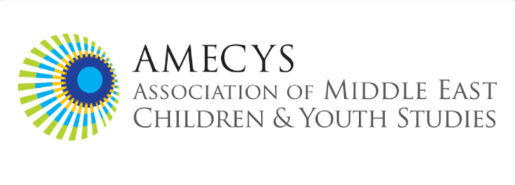

AMECYS Graduate Student Mentorship Program
Mentor Application for 2026 Program

About the Program
The Association of Middle East Children and Youth Studies (AMECYS) Graduate Student Mentorship Program seeks to connect graduate students with established scholars who share overlapping research interests. This inaugural program responds to graduate student needs for greater interaction with specialists in Middle Eastern, North African, Gulf children and youth studies.

Program Duration: February 2026 - February 2027

Program Guidelines & Expectations

Mentor Contribution
As a mentor in the AMECYS program, you would:
- Share your expertise with an emerging scholar in our field over the duration of the 12 month period
- Provide guidance based on your professional experience and research
- Communicate and schedule via email or your preferred method at least once a month
- Meet via video call, phone, or in person with your mentee for approximately 1 hour every month
- Offer insights on topics within your area/s of expertise
- Support the growth of Middle Eastern and North African children and youth studies

Time Commitment and Mentor Responsibilities
We recognize and deeply appreciate that you are volunteering your valuable time.
The program is designed to be:
- Flexible in timing and communication methods
- Focused on areas of your expertise and interest/s
- Manageable alongside your existing responsibilities
- The minimum time commitment is 1 hour every month, the maximum is up to you

I am committed to contributing to the AMECYS mentorship program as a mentor in accordance with the guidance stated in this application.

Signature: _____________________________________ Date: ________________

Thank you for your willingness to support emerging scholars in Middle Eastern and North African children and youth studies. Your expertise and guidance will be invaluable to the next generation in our field!

MENTOR APPLICATION FORM

Application Deadline: December 17, 2025, Notification Date: mid- January, 2025

Program Launch: February 2026

To apply, complete the application form here: https://forms.gle/VctBGAf4uUVEZYWj8

For any questions, contact AMECYS Graduate Committee: Melis Sulos, melissulos@gmail.com, Hilary Falb Kalisman, hilary.kalisman@colorado.edu and Rustem Ertug Altinay, ertug.altinay@unimi.it

