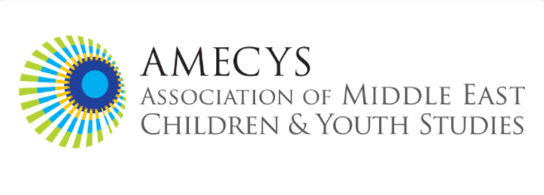
AMECYS Graduate Student Academic Mentorship Program
Mentee Application for 2026 Program Instructions and Agreement
About the Program
The Association of Middle East Children and Youth Studies (AMECYS) Graduate Student Mentorship Program pairs graduate student members with established scholars who share overlapping research interests. This inaugural program responds to the need for greater opportunities for engagement with specialists in Middle Eastern, North African and Gulf children and youth studies.

Program Duration: February 2026 - February 2027

Eligibility Criteria
To be eligible for the AMECYS Mentorship Program, applicants must:
- Be enrolled in a Ph.D. program and be in good standing
- Be current paid AMECYS members at the time of application and maintain paid membership throughout the mentoring year.
- Be studying topics related to Middle Eastern, North African, and Gulf children/youth and/or their diasporic communities
- Commit to participating for the full 12-month duration

Program Guidelines & Expectations

Mentee Participation
As a mentee in the AMECYS program, you would:
- Engage with an established scholar in our field.
- Seek guidance based on your mentor’s professional experience and research.
- Communicate and schedule via email or your mentor’s preferred method at least once a month.
- Meet via video call, phone or in person with your mentor for approximately one hour every month.
- Discuss topics within your area(s) of interest and professional development
- Contribute to the growth of Middle Eastern and North African children and youth studies.

Time Commitment and Mentee Responsibilities
Bearing in mind reasonable mentorship time allotments and expectations, this program is designed to be:
• Flexible in timing and communication methods
• Focused on your areas of interest and research development
• Manageable with your academic program

As a mentee, you are expected to:
• Communicate with your mentor regularly via email or your mentor’s preferred method
• Be proactive in scheduling and maintaining contact
• Come prepared to meetings with specific questions or topics for discussion
The minimum time commitment is 1 hour every month, the maximum is up to your mentor

Commitment Statement
I commit to participating in the AMECYS mentorship program in accordance with the guidance stated in this application.

Applicant Signature: ______________________________________________ Date: ________________
The AMECYS Graduate Student Mentorship Program is designed to foster the next generation of scholars in Middle Eastern, North African and Gulf children and youth studies. AMECYS looks forward to supporting your academic and professional development!

AMECYS ACADEMIC MENTORSHIP PROGRAM MENTEE APPLICATION FORM

Application Deadline: December 17, 2025, Notification Date: mid- January, 2025

Program Launch: February 2026

To apply, submit items # 1 and #2 below, collated as a single pdf or word document, to: amecystudies@gmail.com and write “Academic Mentee Application” in subject heading, and visit the link in item # 3 to submit the application form.

- A short biography (one paragraph maximum)
- CV
- Completed Application Form: available to submit here:
https://forms.gle/iBXEE64hKWR8uoMNA

For any questions, contact AMECYS Graduate Committee: Melis Sulos, melissulos@gmail.com, Hilary Falb Kalisman, hilary.kalisman@colorado.edu , and Rustem Ertug Altinay, ertug.altinay@unimi.it

